Project 3 – Data Visualization

Life Expectancy by Country

Lori Bissell, Zac Blankenship, Demetria Horton, Shelby McDaniel, Elcia Wesley

**Topic:**

Our group will be looking at the life expectancy by country. “Life expectancy, averaging a person's lifespan from birth to death, varies globally due to factors like genetics, lifestyle, and healthcare access.” We will be looking at the data and breaking it down by gender and year per country.

**Data:**

The data provided is from the United Nations (UN) and World Bank (WB). There is gendered data from both UN and WB. Our team will be using the data provided by the UN. There are 229 countries included in the dataset. The UN data also provides data over the years (1950-2101). Our team will need to decide what data we need, then ensure the data is cleaned and ready for import into a database, before creating our visualizations.

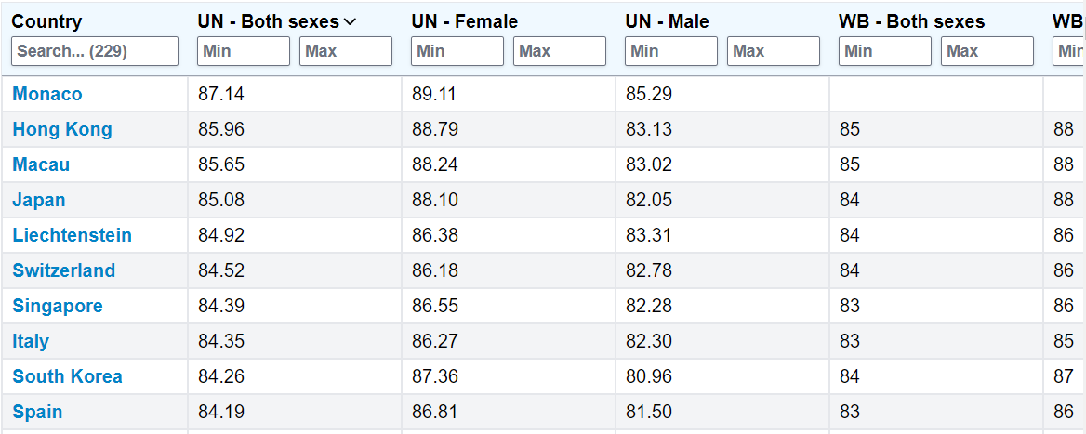

<https://worldpopulationreview.com/country-rankings/life-expectancy-by-country>

Links to the original UN data:

* Sexes combined: <https://data.un.org/Data.aspx?q=life+expectancy&d=PopDiv&f=variableID%3a68>
* Males: <https://data.un.org/Data.aspx?q=life+expectancy&d=PopDiv&f=variableID%3a66>
* Females: <https://data.un.org/Data.aspx?q=life+expectancy&d=PopDiv&f=variableID%3a67>

**Sample Visualizations We Want to Create:**

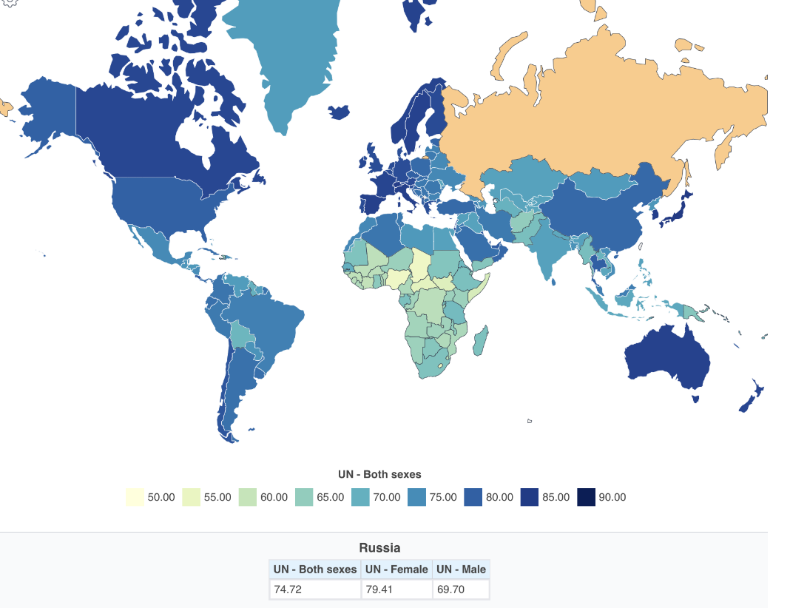

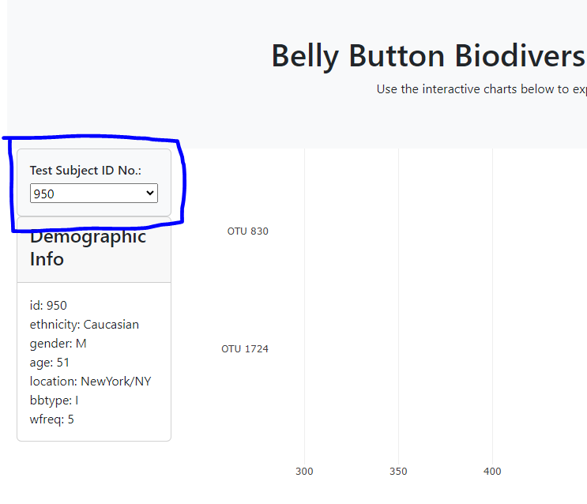

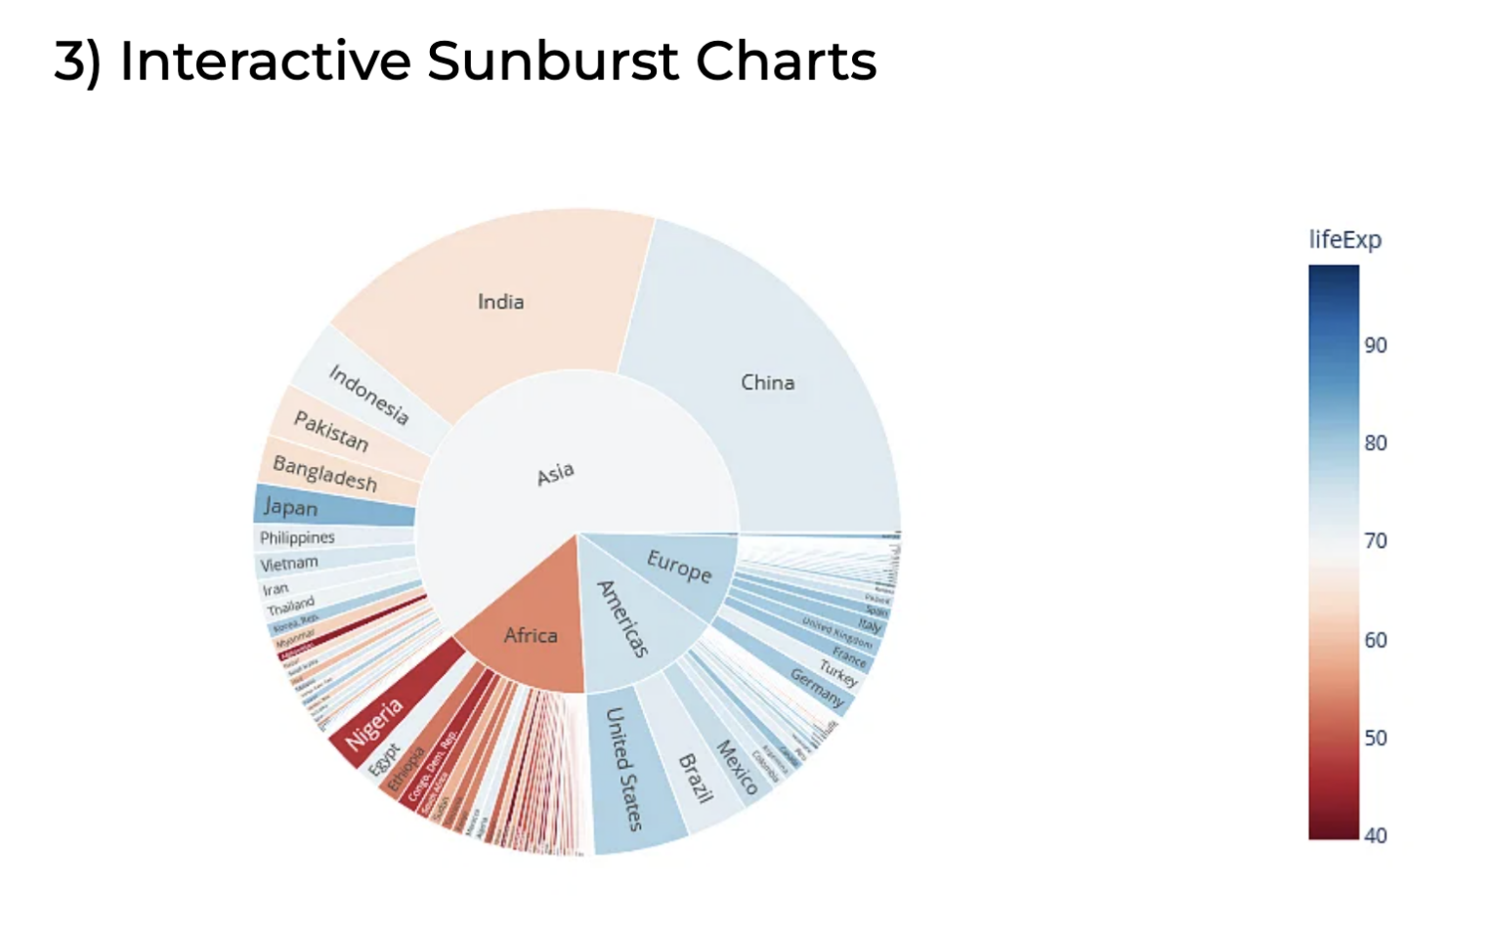

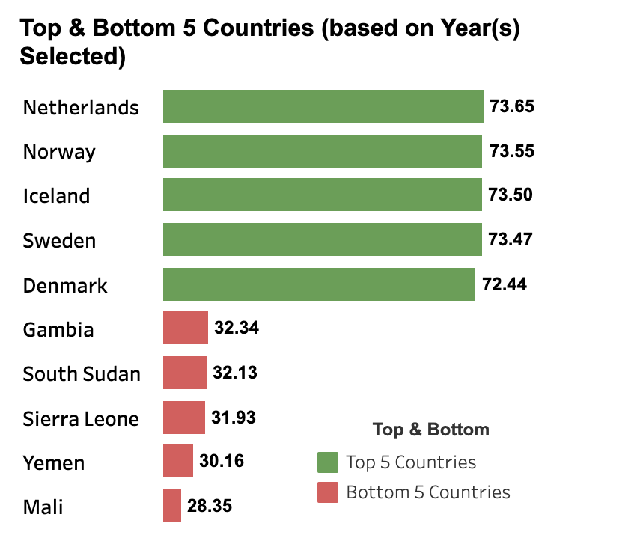

**Sketch of the final design:**

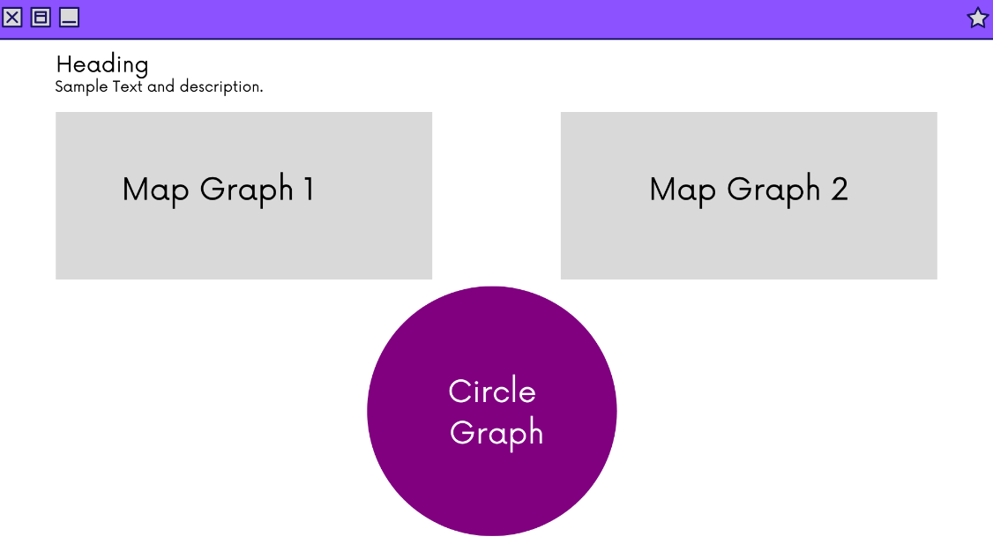

**Project Assignments:**

* Shelby: GitHub manager, load and clean D=data
* Zac: map and hover boxes
* Lori: drop down
* Demetria: pie chart, ReadMe
* Elcia: Bar chart

**GitHub Link:**

https://github.com/symcd2020/Data_Visualization_Project-LifeExpectancyByCountry.git

References: <https://worldpopulationreview.com/country-rankings/life-expectancy-by-country>